Celebrate/Commemorate Memorial Day
Waterloo Remembers
Co Chairs: Jane Shaffer, Sessler Companies, 315-539-3353
Dave Duprey, Waterloo Village Deputy Mayor, 315-521-9715
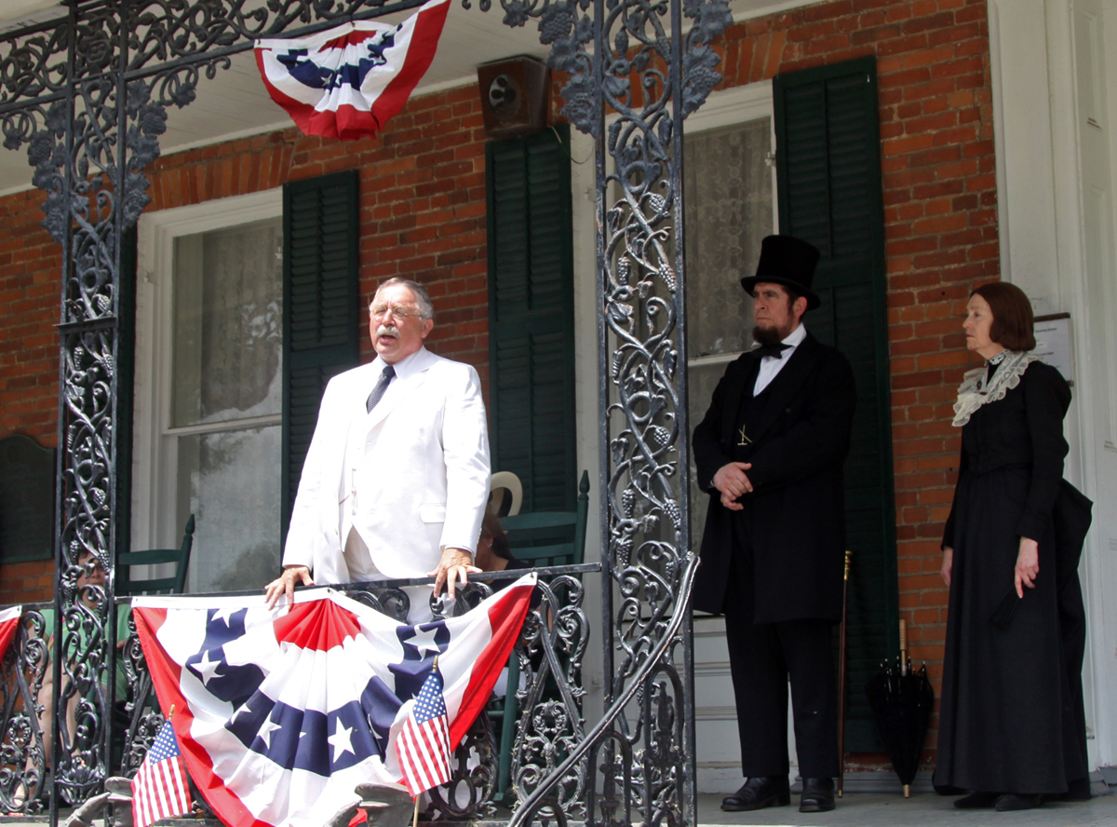

Teddy Roosevelt, Abe Lincoln and Clara Barton at the National Memorial Day Museum public press conference last year. Photo by Darlene Dprey

FOR IMMEDIATE RELEASE

CELEBRTIES WILL GATHER
AT CELEBRATE COMMEMORATE

WATERLOO – You never can tell whom you may meet at Celebrate Commemorate. Reenactors portraying presidents and historical figures will mingle with the crowds throughout the village.
The popular Gig Young as Teddy Roosevelt and local actress Eleanor Sterns as Clara Barton will be joined by Fritz Klein as Abraham Lincoln and Carolyn Evans as Harriet Tubman and Sojourner Truth will bring history to life at events from the Creative Expressions awards ceremony on Thursday to the Sunday worship service
Welles Award Reception on Friday, Saturday’s parade and Sunday’s worship service. Not all dignitaries will be at all events, but they are expected to gather on the front porch of the National Memorial Day Museum at 4:30 p.m. Saturday, where the public is invited to ask questions and participate in a press conference.

Making his third visit to Waterloo, Gib Young will portray President Theodore Roosevelt, our nation’s youngest President and the founder of the National Park Service. Young has been a Civil War buff all his life and is a current member of the Ft. Wayne Civil War Roundtable. He is past camp commander of Champion Hill, Camp 17, Sons of Union Veterans of the Civil War and past Indiana Department Commander of that patriotic organization.
Young has been a life long admirer of Theodore Roosevelt. He is a member of the Theodore Roosevelt Association. Mr. Roosevelt’s personality, intellect, and zest for life were an irresistible call to Gib. But it wasn’t until about ten years ago that a local teacher convinced Mr. Young to come to a fifth grade class as the 26th President. The ‘challenge’ and fun of that small event led to an acceleration of study of ‘TR’s’ history and a development of period clothing and spectacles.
A fortuitous meeting six years ago with Mr. Fritz Klein, the foremost Abraham Lincoln interpreter today convinced Young to become a professional interpreter himself. Mr. Klein felt that Young’s Theodore Roosevelt impression was the best he had ever seen. Besides the physical resemblance of Theodore Roosevelt – circa 1915 – Mr. Young has been able to develop the vocal and movements of his subject to a high degree.
Considered one of the nation’s foremost Lincoln actors, Richard F. (Fritz) Klein makes Lincoln and his period of history come alive. Klein began acting as a hobby in 1975. The first time he was asked to portray Abraham Lincoln was in 1976 at a municipal celebration of the nation’s bicentennial. He began acting fulltime in 1980. Since then, the role has taken him to 35 states for film and television, on stage, and as a motivational speaker. He now resides in Springfield, Illinois, with his wife and family, where he performs for some of the city’s 500,000 annual visitors. From there he also travels to points across the nation on tours and by special invitation.

Klein will deliver the keynote address at the 5th annual Illumination and Remembrance ceremony at the American Civil War Memorial at 8:30 p.m. Friday. And will speak at the Living History encampment on Oak Island at 1:15 and 3 p.m. and will deliver the Emancipation Proclamation at 6:30 p.m. on Saturday, May 26.

Carolyn Evans is known for bringing history to life through her interactive dramatic presentations accompanied by dynamic drumming for a Ghanaian-styled drum and dance ensemble. She uses poetry and dance to portray the lives of courageous women. She will speak on Harriet Tubman and the Underground Railroad at 1, 3 and 6 p.m. Saturday, May 26, at Oak Island encampment pavilion 2, and will speak about slavery as Sojourner Truth at 10:15 a.m. on Sunday, May 27.

Eleanor Stearns, historical actor, has researched and written portrayals of Clara Barton, Emily Dickinson, Amelia Earhart, and Elizabeth Cady Stanton. She performs her “Women of Vision” for schools and organizations, hoping to bring history alive for her audiences. Ms. Stearns is a graduate of Drew University and was employed as a School Psychology Technician with the Geneva City Schools until her retirement. She is an active member and past president of the Geneva Theatre Guild and has performed in many plays. Among her favorite roles are her performances in “The Belle of Amherst”, “The Gin Game”, and “Death of a Salesman”. In 2005 she received an outstanding performance award at the Theatre Association of New York State Festival for her portrayal of Anastasia in the one-act play “Foibles”.

Ms. Stearns’ portrayal of Clara Barton gives glimpses of her life, her involvement during the Civil War, and her role in the founding and activities of the American Red Cross. She will also read portions of a Memorial Day address that Miss Barton delivered in Dansville, NY. Ms. Stearns developed this presentation after extensive research and visitations to Clara Barton’s birthplace and gravesite in North Oxford, Massachusetts. She also visited Dansville where the first chapter of the American Red Cross was founded and studied original letters and documents at their Red Cross Headquarters. In May 2004 she was honored to portray Clara Barton at Miss Barton’s final home and Red Cross Headquarters in Glen Echo, Maryland on the 100th anniversary of her resignation as President of the American Red Cross.

The 13th annual Celebrate Commemorate event will be held May 25-27 in Waterloo, the Birthplace of Memorial Day. For more information about the events, go to www.waterloony.com.

The 146th consecutive commemoration of Memorial Day will be on Wednesday, May 30. It will include prayer services, and the official Memorial Day parade at 6 pm coordinated by the VFW.


